Assignment 2

Task 1:Sales By Customer.

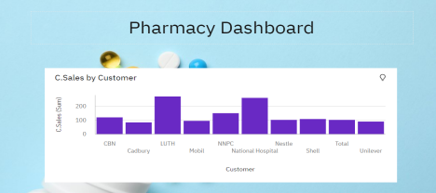Task 2:Sales By Location.

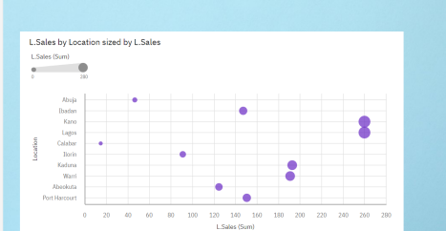

Task 3:Sales By Sales Representative.

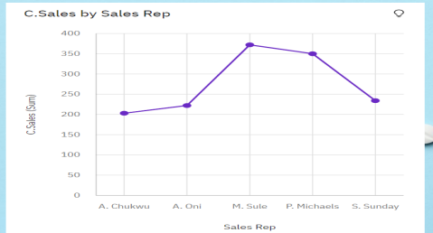

Task 4: Received Inventory From Supplier

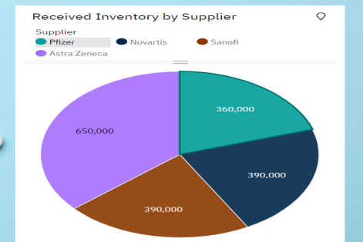

Task 5: Inventory Stock for Warehouse Locations

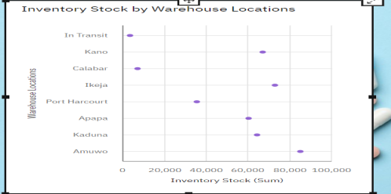Task 6: Sales Trend

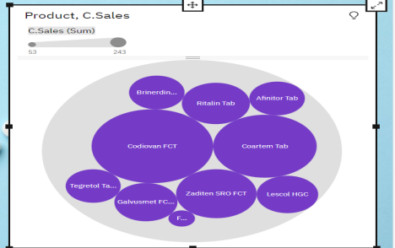

Task 7:Monthly Sales

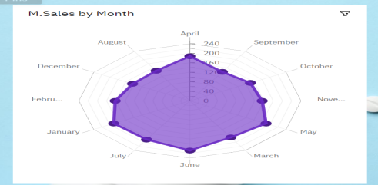Task 8: Actual and Received Inventory by Month

